
Company
Logotype

Cone Beam Computed Tomography- Report



Porur Dental X-rays & CBCT

Patient Name : Mr. Sridhar | Date of Report : 07.11.2025
Age/ Gender : 55 years/ Male | Region of Interest : CBCT Sectional Mandible
Referring doctor: Dr. Balamurali Sai | Indication : Fracture and periapical assessment
Clinical Notes: Nil
PATIENT INFORMATION

CBCT- Sectional Mandible provided
CBCT – IMAGE DETAILS

RADIOGRAPHIC INTERPRETATION

- In relation to 45, 46, 47, hyperdense crown structure is evident.
- In relation to 47, there is disto-proximal hypodense cavity involving the crown, and approximating the pulp, with presence of periodontal ligament space widening along with a diffuse periapical hypodensity measuring 5.69 x 6.02x 6.8 mm in dimension.
- The tooth 45 is present with a thin hypodense line, extending along the CEJ mesio distally. The hypodense line is visible towards the lingual portion and is evident in most of the sagittal sections that involve the tooth 45 and also appears to involve the pulp of 45.
- Dental caries: 44
- The alveolar bone in relation to mandible is present with normal trabecular pattern.

RADIOGRAPHIC IMPRESSION

- Dental caries with periapical abscess: 47
- Partially fractured crown: 45
- Dental Caries: 44

Kindly correlate with clinical findings


IMAGES FOR REFERENCE

RECONSTRUCTED PANORAMIC VIEW
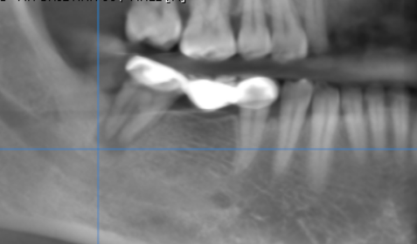

3-DIMENSIONAL VIEW

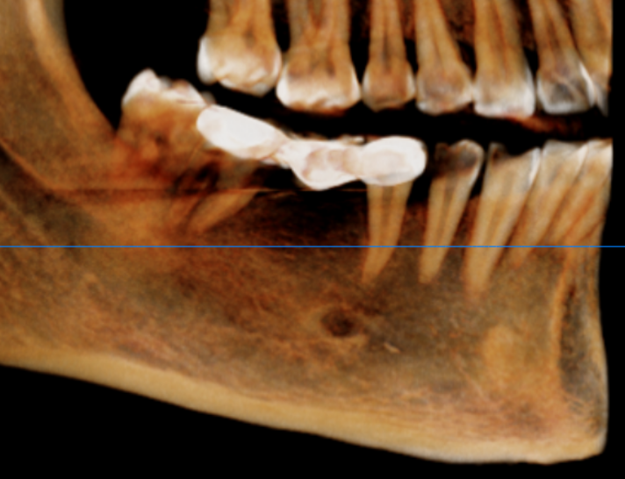

Hypodense Fracture line

45 region- Sagittal view | 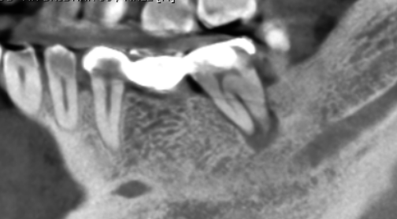
47 region- Sagittal view | 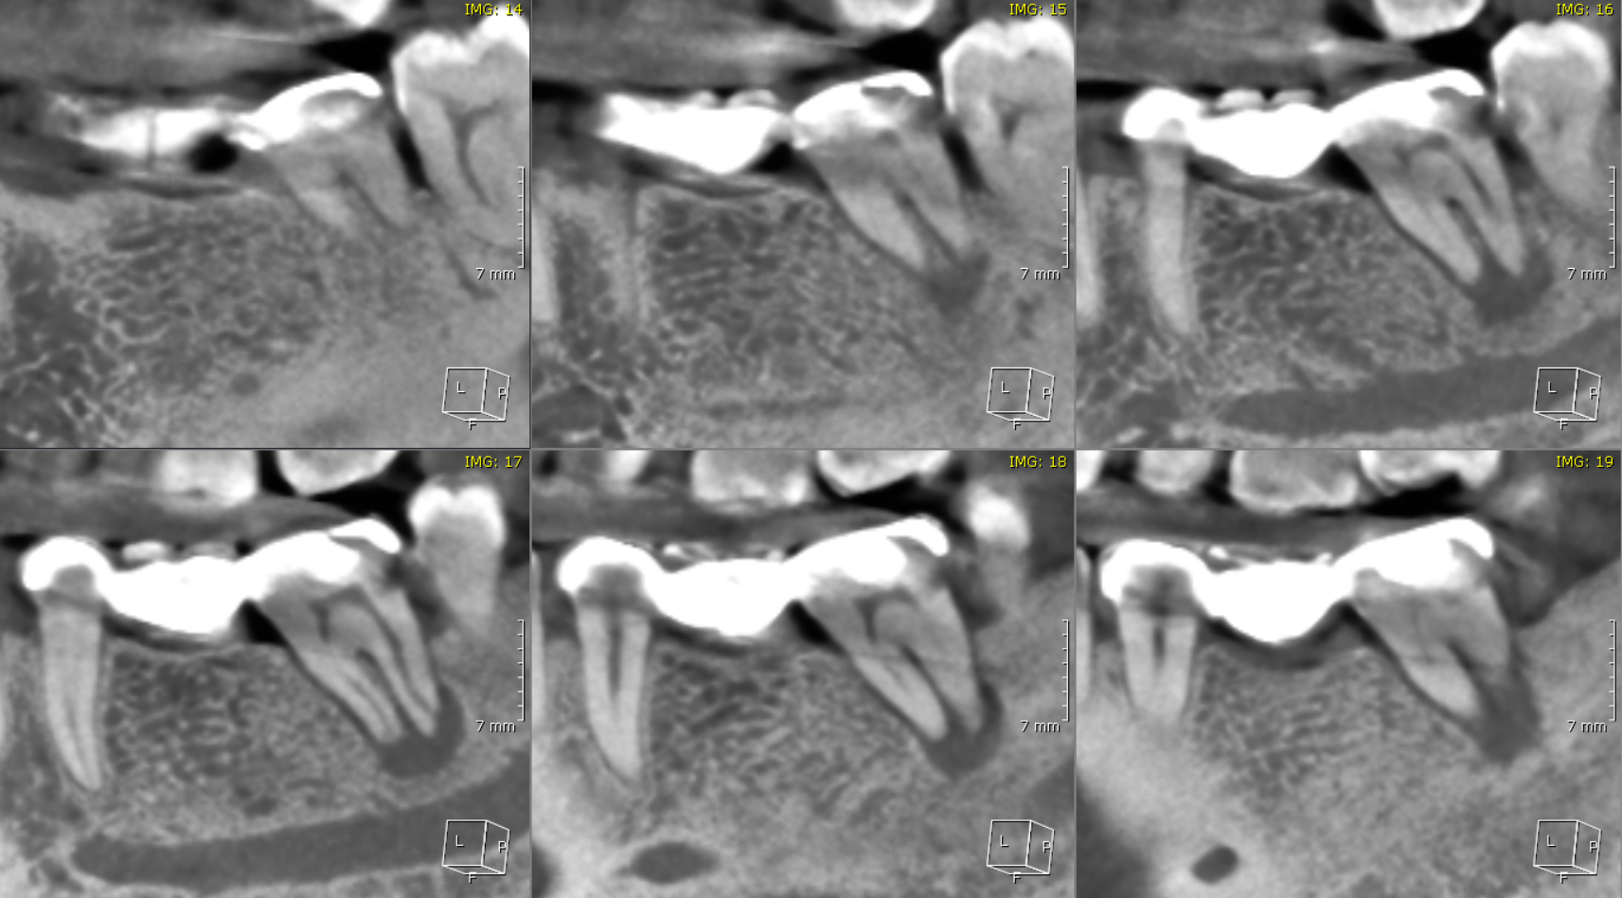
45 region- coronal view | 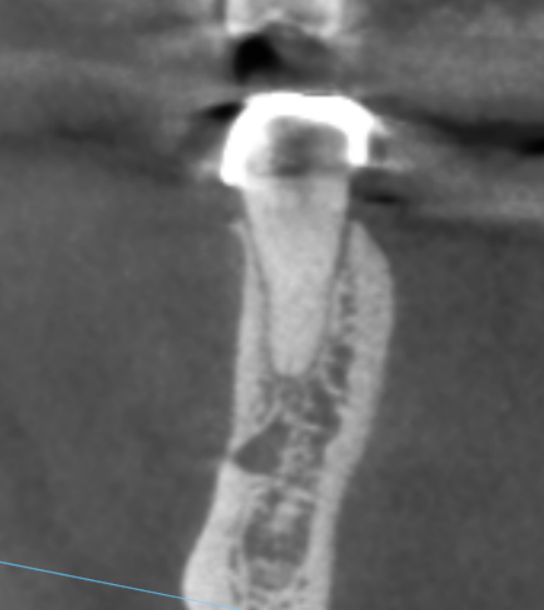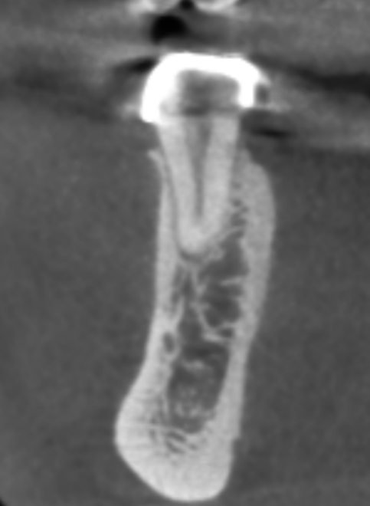

**** End of report ****

